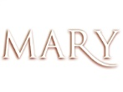
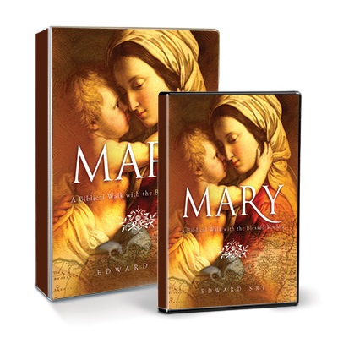

MARY BIBLE STUDY SESSION CALENDAR
Sacred Heart Parish, Notre Dame
January 15-March 5/12, 2015

Session # | SESSION NAME | Thursday Morning  9:30-11:30 AM
1 | Introduction  “Behold, I am the handmaid of the Lord…” | 1/15/15
2 | The Annunciation Luke 1:26-38  “…and the Virgin’s mane was Mary.” | 1/22/15
3 | The Visitation Luke 1:39-56  “Blessed are you among w omen,  and blessed is the fruit of your womb!” | 1/29/15
4 | The Nativity Luke 2:1-20  “And [Mary] gave birth to her first-born son…” | 2/5/15
5 | The Presentation and The Finding of Jesus in the Temple Luke 2:21-52  …”and a sword will pierce through your own soul also…” | 2/12/15
6 | The Wedding at Cana John 2:1-11  “Do whatever he tells you.” | 2/19/15
7 | Mary at the Cross John 19:25-30  “Woman, behold, your son!’ Then he said to the disciple, “Behold, your mother!’” | 2/26/15
8 | Mary Crowned with Glory Revelation 12  “…and on her head a crown of twelve stars…” | 3/5/15
 | Inclement Weather Date – if needed | 3/12/15

Mary: A Biblical Walk with the Blessed Mother is an extraordinary pilgrimage that reveals Mary's unique role in God's Kingdom and in our lives. Filmed on location in the Holy Land, Mary: A Biblical Walk with the Blessed Mother, will place you in the midst of the powerful drama of her earthly life, taking you through her joys...and her sorrows. You will learn how she works in our lives today, drawing us ever closer to her Divine Son. Seeing Mary in this way will change you forever. Mary will become a part of your daily life, and in your daily life, you will become more like Christ.

Why is Mary so important to us?
As Catholics, we have a profound reverence for the Blessed Mother. We turn to her in prayer, in the Mass, in the Rosary, and in Marian devotions. We honor her with special feasts celebrating the significant events in her life. We place images of her in our churches and homes.

The better we know Mary, the better we will know her Son.
http://biblestudyforcatholics.com/category/catholic-bible-study/making-mary/
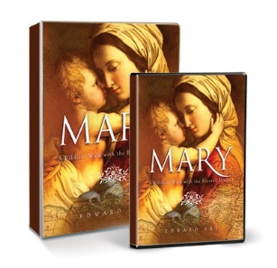
REGISTRATION FORM

Mary: A Biblical Walk with the Blessed Mother

Sacred Heart Parish Center, Notre Dame
Thursdays, beginning January 15, thru March5/12, 2015 –9:30-11:30 AM

Please Pre-register before January 15th in one of the following ways:
Return this form to Michelle Kriss at Sacred Heart Parish Center,
email this form to mkriss@nd.edu, call 631-7508

The first session will be an important orientation for all new participants
Final registration deadline is January 22, 2015

For further detailed information/video clip visit:
http:biblestudyforcatholics.com/category/catholic-bible-study/making-mary

FIRST  NAME: |  |  |  |  | LAST  NAME:
ADDRESS: |  |  |  |  | HOME#:
CITY/STATE  /ZIP: |  |  |  |  | CELL#:
EMAIL: |  |  |  |  | WORK#:
AGE RANGE |  | 18 - 35 |  | 36 - 45 |  |  | 46 - 55 |  | 55+
BIBLE LEVEL: |  | None |  | Some |  |  | Average |  | Advanced
SPECIAL NEEDS REQUEST: |  |  | Handicapped Accessibility |  |  | Other:
* Classes are held on the lower level – no elevator service is available

REGISTRATION FEE: |  | $28.00* |  | PAYABLE TO: |  | Sacred Heart Parish
*FEE: $28.00 per person to cover cost of study binder & materials
If you need financial assistance, please call Michelle Kriss directly at: 631-7508
FOR OFFICE USE ONLY
DATE PAID: |  |  | CASH: |  | CHECK #:

